README 20130570 전철호

제출물: 소스코드, 실행가능파일, 간단한 메뉴얼

소스코드: Please refer to main.py. It is within the zip file I attached, or you can clone it from https://github.com/adobecs5/automata2015/tree/master/1

실행가능파일: please refer to main.py

(how to execute: regardless of OS, open your terminal and type “python3 main.py”)

(This code needs python3 to run. It is coded with python 3.4.3)

간단한 메뉴얼:

1. Start the program by typing “python3 main.py” on the directory you downloaded the files.

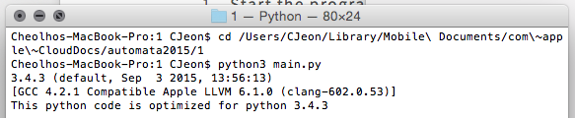

This will automatically print the python version you are on.

If you run this code on python2, you will see the error below



1. After successfully running the data, you will be asked to provide a datapath for DFA data.

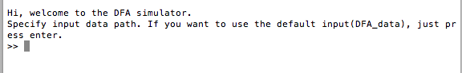

You could either provide your own datapath or choose to use provided test input.